**MY SQL QUERIES**

**COFFEE SHOP SALES PROJECT**

**CONVERT DATE (transaction_date) COLUMN TO PROPER DATE FORMAT**

UPDATE coffee_shop_sales

SET transaction_date = STR_TO_DATE(transaction_date, '%d-%m-%Y');

**ALTER DATE (transaction_date) COLUMN TO DATE DATA TYPE**

ALTER TABLE coffee_shop_sales

MODIFY COLUMN transaction_date DATE;

**CONVERT TIME (transaction_time) COLUMN TO PROPER DATE FORMAT**

UPDATE coffee_shop_sales

SET transaction_time = STR_TO_DATE(transaction_time, '%H:%i:%s');

**ALTER TIME (transaction_time) COLUMN TO DATE DATA TYPE**

ALTER TABLE coffee_shop_sales

MODIFY COLUMN transaction_time TIME;

**DATA TYPES OF DIFFERENT COLUMNS**

DESCRIBE coffee_shop_sales;

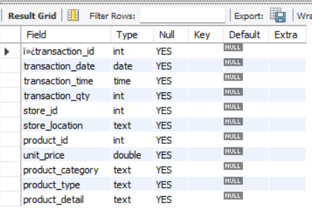

**CHANGE COLUMN NAME `ï»¿transaction_id` to transaction_id**

ALTER TABLE coffee_shop_sales

CHANGE COLUMN `ï»¿transaction_id` transaction_id INT;

**TOTAL SALES**

SELECT ROUND(SUM(unit_price * transaction_qty)) as Total_Sales

FROM coffee_shop_sales

WHERE MONTH(transaction_date) = 5 -- for month of (CM-May)

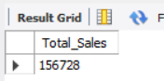

**TOTAL SALES KPI - MOM DIFFERENCE AND MOM GROWTH**

SELECT

MONTH(transaction_date) AS month,

ROUND(SUM(unit_price * transaction_qty)) AS total_sales,

(SUM(unit_price * transaction_qty) - LAG(SUM(unit_price * transaction_qty), 1)

OVER (ORDER BY MONTH(transaction_date))) / LAG(SUM(unit_price * transaction_qty), 1)

OVER (ORDER BY MONTH(transaction_date)) * 100 AS mom_increase_percentage

FROM

coffee_shop_sales

WHERE

MONTH(transaction_date) IN (4, 5) -- for months of April and May

GROUP BY

MONTH(transaction_date)

ORDER BY

MONTH(transaction_date);

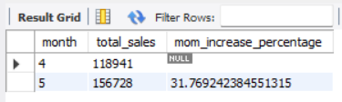

**TOTAL ORDERS**

SELECT COUNT(transaction_id) as Total_Orders

FROM coffee_shop_sales

WHERE MONTH (transaction_date)= 5 -- for month of (CM-May)

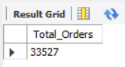

**TOTAL ORDERS KPI - MOM DIFFERENCE AND MOM GROWTH**

SELECT

MONTH(transaction_date) AS month,

ROUND(COUNT(transaction_id)) AS total_orders,

(COUNT(transaction_id) - LAG(COUNT(transaction_id), 1)

OVER (ORDER BY MONTH(transaction_date))) / LAG(COUNT(transaction_id), 1)

OVER (ORDER BY MONTH(transaction_date)) * 100 AS mom_increase_percentage

FROM

coffee_shop_sales

WHERE

MONTH(transaction_date) IN (4, 5) -- for April and May

GROUP BY

MONTH(transaction_date)

ORDER BY

MONTH(transaction_date);

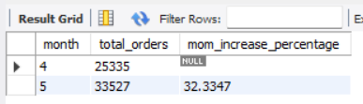

**TOTAL QUANTITY SOLD**

SELECT SUM(transaction_qty) as Total_Quantity_Sold

FROM coffee_shop_sales

WHERE MONTH(transaction_date) = 5 -- for month of (CM-May)

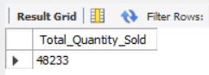

**TOTAL QUANTITY SOLD KPI - MOM DIFFERENCE AND MOM GROWTH**

SELECT

MONTH(transaction_date) AS month,

ROUND(SUM(transaction_qty)) AS total_quantity_sold,

(SUM(transaction_qty) - LAG(SUM(transaction_qty), 1)

OVER (ORDER BY MONTH(transaction_date))) / LAG(SUM(transaction_qty), 1)

OVER (ORDER BY MONTH(transaction_date)) * 100 AS mom_increase_percentage

FROM

coffee_shop_sales

WHERE

MONTH(transaction_date) IN (4, 5) -- for April and May

GROUP BY

MONTH(transaction_date)

ORDER BY

MONTH(transaction_date);

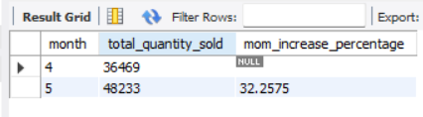

**CALENDAR TABLE – DAILY SALES, QUANTITY and TOTAL ORDERS**

SELECT

SUM(unit_price * transaction_qty) AS total_sales,

SUM(transaction_qty) AS total_quantity_sold,

COUNT(transaction_id) AS total_orders

FROM

coffee_shop_sales

WHERE

transaction_date = '2023-05-18'; --For 18 May 2023

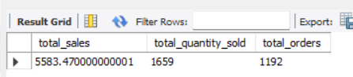

***If you want to get exact Rounded off values then use below query to get the result:***

SELECT

CONCAT(ROUND(SUM(unit_price * transaction_qty) / 1000, 1),'K') AS total_sales,

CONCAT(ROUND(COUNT(transaction_id) / 1000, 1),'K') AS total_orders,

CONCAT(ROUND(SUM(transaction_qty) / 1000, 1),'K') AS total_quantity_sold

FROM

coffee_shop_sales

WHERE

transaction_date = '2023-05-18'; --For 18 May 2023

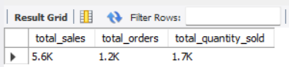

**SALES TREND OVER PERIOD**

SELECT AVG(total_sales) AS average_sales

FROM (

SELECT

SUM(unit_price * transaction_qty) AS total_sales

FROM

coffee_shop_sales

WHERE

MONTH(transaction_date) = 5 -- Filter for May

GROUP BY

transaction_date

) AS internal_query;

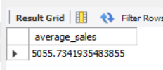

**DAILY SALES FOR MONTH SELECTED**

SELECT

DAY(transaction_date) AS day_of_month,

ROUND(SUM(unit_price * transaction_qty),1) AS total_sales

FROM

coffee_shop_sales

WHERE

MONTH(transaction_date) = 5 -- Filter for May

GROUP BY

DAY(transaction_date)

ORDER BY

DAY(transaction_date);

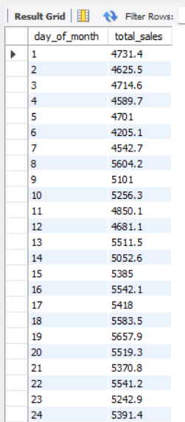 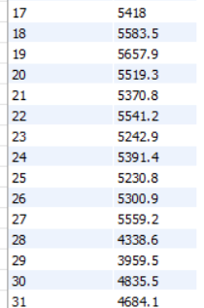

***COMPARING DAILY SALES WITH AVERAGE SALES – IF GREATER THAN “ABOVE AVERAGE” and LESSER THAN “BELOW AVERAGE”***

SELECT

day_of_month,

CASE

WHEN total_sales > avg_sales THEN 'Above Average'

WHEN total_sales < avg_sales THEN 'Below Average'

ELSE 'Average'

END AS sales_status,

total_sales

FROM (

SELECT

DAY(transaction_date) AS day_of_month,

SUM(unit_price * transaction_qty) AS total_sales,

AVG(SUM(unit_price * transaction_qty)) OVER () AS avg_sales

FROM

coffee_shop_sales

WHERE

MONTH(transaction_date) = 5 -- Filter for May

GROUP BY

DAY(transaction_date)

) AS sales_data

ORDER BY

day_of_month;

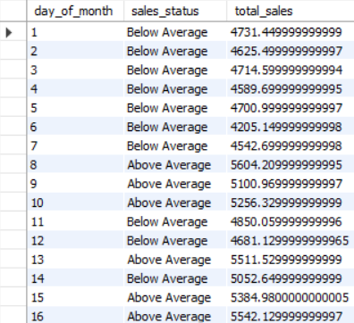 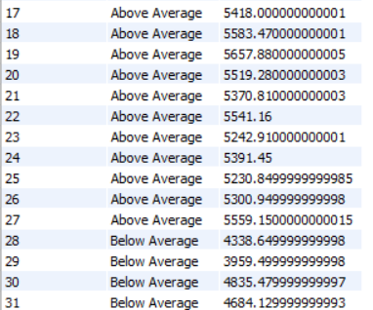

**SALES BY WEEKDAY / WEEKEND:**

SELECT

CASE

WHEN DAYOFWEEK(transaction_date) IN (1, 7) THEN 'Weekends'

ELSE 'Weekdays'

END AS day_type,

ROUND(SUM(unit_price * transaction_qty),2) AS total_sales

FROM

coffee_shop_sales

WHERE

MONTH(transaction_date) = 5 -- Filter for May

GROUP BY

CASE

WHEN DAYOFWEEK(transaction_date) IN (1, 7) THEN 'Weekends'

ELSE 'Weekdays'

END;

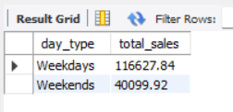

**SALES BY STORE LOCATION**

SELECT

store_location,

SUM(unit_price * transaction_qty) as Total_Sales

FROM coffee_shop_sales

WHERE

MONTH(transaction_date) =5

GROUP BY store_location

ORDER BY SUM(unit_price * transaction_qty) DESC

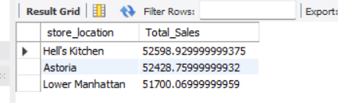

**SALES BY PRODUCT CATEGORY**

SELECT

product_category,

ROUND(SUM(unit_price * transaction_qty),1) as Total_Sales

FROM coffee_shop_sales

WHERE

MONTH(transaction_date) = 5

GROUP BY product_category

ORDER BY SUM(unit_price * transaction_qty) DESC

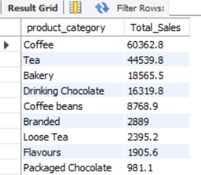

**SALES BY PRODUCTS (TOP 10)**

SELECT

product_type,

ROUND(SUM(unit_price * transaction_qty),1) as Total_Sales

FROM coffee_shop_sales

WHERE

MONTH(transaction_date) = 5

GROUP BY product_type

ORDER BY SUM(unit_price * transaction_qty) DESC

LIMIT 10

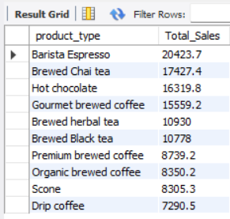

**SALES BY DAY | HOUR**

SELECT

ROUND(SUM(unit_price * transaction_qty)) AS Total_Sales,

SUM(transaction_qty) AS Total_Quantity,

COUNT(*) AS Total_Orders

FROM

coffee_shop_sales

WHERE

DAYOFWEEK(transaction_date) = 3 -- Filter for Tuesday (1 is Sunday, 2 is Monday, ..., 7 is Saturday)

AND HOUR(transaction_time) = 8 -- Filter for hour number 8

AND MONTH(transaction_date) = 5; -- Filter for May (month number 5)

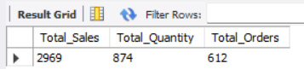

***TO GET SALES FROM MONDAY TO SUNDAY FOR MONTH OF MAY***

SELECT

CASE

WHEN DAYOFWEEK(transaction_date) = 2 THEN 'Monday'

WHEN DAYOFWEEK(transaction_date) = 3 THEN 'Tuesday'

WHEN DAYOFWEEK(transaction_date) = 4 THEN 'Wednesday'

WHEN DAYOFWEEK(transaction_date) = 5 THEN 'Thursday'

WHEN DAYOFWEEK(transaction_date) = 6 THEN 'Friday'

WHEN DAYOFWEEK(transaction_date) = 7 THEN 'Saturday'

ELSE 'Sunday'

END AS Day_of_Week,

ROUND(SUM(unit_price * transaction_qty)) AS Total_Sales

FROM

coffee_shop_sales

WHERE

MONTH(transaction_date) = 5 -- Filter for May (month number 5)

GROUP BY

CASE

WHEN DAYOFWEEK(transaction_date) = 2 THEN 'Monday'

WHEN DAYOFWEEK(transaction_date) = 3 THEN 'Tuesday'

WHEN DAYOFWEEK(transaction_date) = 4 THEN 'Wednesday'

WHEN DAYOFWEEK(transaction_date) = 5 THEN 'Thursday'

WHEN DAYOFWEEK(transaction_date) = 6 THEN 'Friday'

WHEN DAYOFWEEK(transaction_date) = 7 THEN 'Saturday'

ELSE 'Sunday'

END;

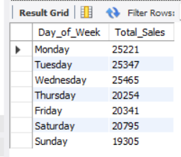

***TO GET SALES FOR ALL HOURS FOR MONTH OF MAY***

SELECT

HOUR(transaction_time) AS Hour_of_Day,

ROUND(SUM(unit_price * transaction_qty)) AS Total_Sales

FROM

coffee_shop_sales

WHERE

MONTH(transaction_date) = 5 -- Filter for May (month number 5)

GROUP BY

HOUR(transaction_time)

ORDER BY

HOUR(transaction_time);

